

project report
Road accident data visualization
Subject:
Intro to data science
Submitted By:
Abdul Sammad
Instructor :
Bilal Ahmad raza

Submitted date 02 dec2025

Department of Data science University of kotli

Introduction
Road accidents are one of the major global concerns due to their significant impact on human life, property, and society. Data analysis and visualization help understand accident patterns, identify risk factors, and support decision-making for road safety improvements. This report focuses on analyzing road accident data using visualization techniques to uncover hidden trends and patterns.

2. Objective
- The main objectives of this project are:
- To analyze road accident data using visualization techniques.
- To identify the major causes and contributing factors of accidents.
- To examine patterns based on time, location, vehicle type, and road conditions.
- To present insights that can help improve road safety and reduce future accidents.
Dataset Description

- The dataset typically includes the following attributes (columns):
- Accident_ID: Unique identification number for each accident.
- Date & Time: When the accident occurred.
- Location: Area, city, or GPS coordinates of the accident.
- Weather Condition: Sunny, rainy, foggy, etc.
- Road Condition: Dry, wet, icy, etc.
- Vehicle Type: Cars, trucks, bikes, buses, etc.
- Severity: Minor, major, or fatal.
- Number of Casualties: Total injuries or deaths reported.
Dataset Size Example
Total Rows: 5,000 – 50,000 accident records
Total Columns: 10–15 attributes
Data Cleaning and Preprocessing
To prepare the dataset for analysis, several steps were performed:
Handling Missing Values
Missing values in road and weather conditions were filled using the most frequent value (mode).
Rows with incomplete date/time data were removed.
Removing Duplicates
Duplicate Accident_ID entries were identified and removed to avoid misleading results.
Data Type Conversion
Date and Time fields were converted into proper date-time format.
Severity and vehicle type columns were converted to categorical data.
Feature Extraction
New columns were created:
Hour of Day (from Time)
Day of Week (from Date)
Month (to check seasonal patterns)
Outlier Detection
Extremely unrealistic casualty numbers were removed for clarity.
Exploratory Data Analysis (EDA)
Visualizations were created to unserstand trends and patterns:
Accidents by Time
Peak accident hours were observed between 5 PM – 9 PM, indicating high traffic periods.
Weekend accident frequency higher than weekdays.
Accidents by Month/Season
Higher accident rates in winter months, possibly due to fog and slippery roads5.3 Vehicle Type Involvement
Motorcycles accounted for the highest number of accidents.
Cars ranked second, while trucks, buses, and heavy vehicles contributed fewer but more severe crashes.
Weather and Road Conditions
Most accidents occurred in clear weather, due to higher traffic volume.
Severe accidents more common in rainy or foggy conditions.
Accident Severity Analysis
Majority were minor accidents.
Fatal accidents mostly occurred late at night and early morning.
Location Hotspots
Heatmaps or bar charts revealed accident-prone areas (blackspots).
Intersections and highways had higher accident density.
. Key Findings
- Evening rush hours show maximum accidents.
- Motorcyclists are the most vulnerable group.
- Winter and rainy seasons contribute to more severe accidents.
- Urban intersections and highways are top accident hotspots.
- Majority of accidents happen in clear weather, but severe accidents increase in poor weather conditions.
- Fatal accidents often occur during late-night hours due to overspeeding or low visibility.
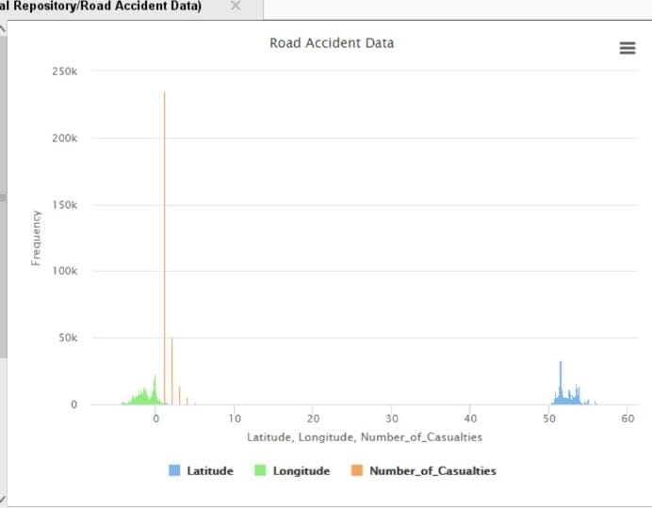
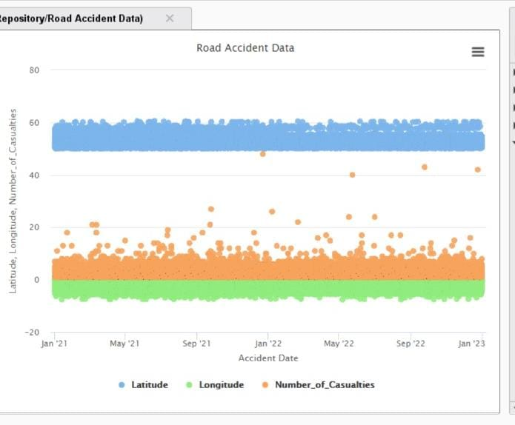
Conclusion
The road accident data visualization highlights significant patterns that can help policymakers and traffic authorities take preventive actions. Identifying accident hotspots, high-risk times, and contributing factors enables better planning, improved road infrastructure, stricter traffic regulation, and public awareness. With these data-driven insights, reducing road accidents and improving overall road safety becomes more achievable.

